**King Khaled University**

**College of Computer Science**

**Department of Information System**

**Assignment**

**(Individual Assignment)**

362 ISM - Business Process Management

Student name: _____________________ ID: ______________

**Instructions:**

1. This assignment will be done individually.
2. Assignment out of 10 Marks.
3. Due date Thursday 9/02/2023.

**Question 1: (5 Marks)**

Consider the sales campaign process model of figure below. Describe which 7PMG guidelines can be used to improve this model.



1. Clearly mention the violated principles from G1 to G7.
2. Then redraw the model after correction.

|  |  |
| --- | --- |
| List of errors |  |
| Model after correction |  |

**Question 2: (5 Marks)**

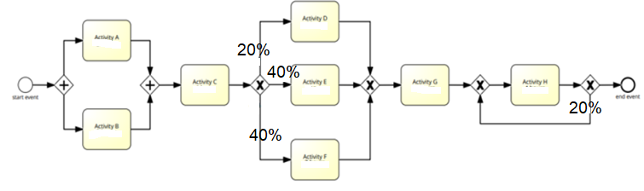Calculate CTE of the following process:

For students ending their last digit of student id with 0,1,2,3

|  |  |  |
| --- | --- | --- |
| **Activity** | **Cycle Time** | **Process Time** |
| Activity A | 2 days | 2 hours |
| Activity B | 1 day | 2 hours |
| Activity C | 1 day | 1 hour |
| Activity D | 2 days | 2 hours |
| Activity E | 2 days | 2 hours |
| Activity F | 1 day | 3 hours |
| Activity G | 1 day | 2 hours |
| Activity H | 4 days | 4 hours |

For students ending their last digit of student id with 4,5,6,

|  |  |  |
| --- | --- | --- |
| **Activity** | **Cycle Time** | **Process Time** |
| Activity A | 1 day | 1 hour |
| Activity B | 1 day | 2 hours |
| Activity C | 1 day | 1 hour |
| Activity D | 1 day | 1 hour |
| Activity E | 2 days | 2 hours |
| Activity F | 1 day | 3 hours |
| Activity G | 1 day | 2 hours |
| Activity H | 3 days | 3 hours |

For students ending their last digit of student id with 7,8,9

|  |  |  |
| --- | --- | --- |
| **Activity** | **Cycle Time** | **Process Time** |
| Activity A | 4 days | 4 hours |
| Activity B | 1 day | 2 hours |
| Activity C | 1 day | 1 hour |
| Activity D | 1 day | 1 hour |
| Activity E | 2 days | 2 hours |
| Activity F | 3 days | 4 hours |
| Activity G | 1 day | 2 hours |
| Activity H | 4 days | 4 hours |